Year 12 ATAR

PHYSICS

Unit 3

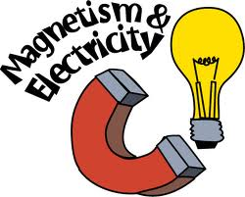

Electromagnetism
ANSWERS

Electrostatically charged objects exert a force upon one another; the magnitude of this force can be calculated using Coulomb’s Law
This includes applying the relationship

FORCES BETWEEN CHARGES – COULOMB’S LAW

- The French physicist, Charles Coulomb (1736-1806) investigated the forces between two charged spheres.
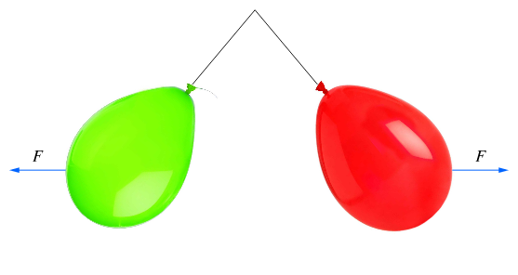
Two similarly charged balloons will repel each other by applying a force on each other.
- He showed that the magnitude of the force, F, varied inversely with the square of the distance between the spheres and varied directly with the product of the charges:

$F= \frac{k q_{1}q_{2}}{r^{2}}$ q₁q₂ = charges on sphere in coulombs (C)
Coulomb's law
d = distance separating charges from centre of charge (m)
k = constant $\frac{1}{4πξ_{0}}$ = 9.00 x 10⁹ N m² C⁻² (use air as the medium)
F = the electrical force in newtons (N)
- The force is also dependent on the material or medium between the charges.
- Unless told otherwise, assume the medium is air or a vacuum so: k = 9.00 x 10⁹ Nm²C⁻².

- Using the force between two charges of 1 C each, placed 1 m apart can calculated.
- The force would be 9.0×10⁹ N, or approximately 10¹⁰ N.
- This is equivalent to the weight provided by a mass of 918 000 tonnes.
- This demonstrates that a 1 C charge is a huge amount of charge.
- In reality, the amount of charge that can be placed on ordinary objects is a tiny fraction of a coulomb.
- Even a highly charged Van de Graaf generator will have only a few microcoulombs (1μC=10⁻⁶ C) of excess charge.

- Two oppositely charged spheres each of 3.00 x 10⁻⁶ C hang 0.200 m apart. What is the force between them?

- NOTE: In the answer a negative sign indicates attraction while a positive sign indicates repulsion. Finish an answer off by removing the sign and stating if the charge is attraction or repulsion
- Two freely hanging charged spheres have a charge of +10.0 nC and -6.00 nC. They are brought together to touch each other and are then released. Once released they settle 8.00 cm apart from each other and remain still. What force do they exert on each other at this time?

- A force of 1.07 x 10⁻¹ N attraction is acting on two small spheres 6.50 cm apart. If one has a charge of +10.0 nC, what is the other charge?

- How far apart are two spheres each of +5.00 μC if there is a force of 22.5 N between them?

- One tiny metal ball carries a charge of +3.00 nC. A second ball, of identical size, shape and material, has a charge of -12.0 nC. The balls are 30.0 mm apart.
- What is the force of attraction between the balls?

- You make the balls touch and then separate them to 30.0 mm again. What is now the force between the balls?

- Nick finds that his clothes are clinging together when he removes them from a clothes-drier. This results from the static charges in the clothes that built up during drying. Nick needs to exert a force of 0.500 N to pull apart two articles of clothing. Calculate the charge on each. Assuming the charges are equal and that the distance between the two articles is 0.800 mm.

- Two identical charges of 1.20 μC are 68.4 cm apart. What is the force between the charges?

- If the two charges in the previous question touch, and the force between them is the same, how far apart are they now?

- Two metal coated table-tennis balls are charged identically and separated by a distance d in air. If the charge on one ball is doubled, the charge on the other tripled and reversed in sign, and the distance between them increased by 25%, how does the new electrostatic force compare to the old?

- An investigation was set up to determine the value of Permittivity in free space – the electric constant${ ε}_{0}$. Two flat parallel aluminium plates could be separately stripped of electrons to give a charge of 2.20 x 10⁻⁷ C on each plate. The bottom plate was placed on a digital balance that read in grams. The balance was set to zero before the plates were charged. When the plates were charged the balance reading could be converted to the electrostatic force of repulsion experienced by the bottom plate. The top plate was clamped firmly in a plastic stand. The separation r between the plates was set with a Vernier gauge.
The relative uncertainty for the mass readings is ±10%.

grams
Parallel plates
Digital balance
Separation r
Separation r  (m) | $\frac{1}{r2}$  (m⁻²) | Balance reading (grams) | $Electrostatic Force$  (N)
0.065 | 234 | 10.51 | 0.103 ± 0.010
0.070 |  | 9.18
0.080 |  | 6.94
0.100 |  | 4.29
0.120 | 69.4 | 3.16 | 0.031 ± 0.003
- Complete the second column of the table for $\frac{1}{r^{2}}$ . Two values have been done for you.

- Complete the fourth column of the table for Electrostatic force and include the appropriate uncertainty range. Two values have been done for you.
- Plot a graph of F versus$\frac{1}{r^{2}}$. You must include a line of best fit and error bars.
Force (N)
0.120

0.100

0.080

0.060

0.040

0.020

0.000
0 50 100 150 200 250
$$\frac{1}{r^{2}} (m^{-2})$$

- Calculate the gradient of your line of best fit from your graph showing all working. (No units are required).

- Determine the experimental value of the electronic constant ${ ε}_{0}$ from the value of the gradient that you obtained. (If you could not determine the gradient use the numerical value 0.00044).

- The diagram shows two charged spheres. Each sphere has a mass of 4.8 kg. Sphere A has a charge of +2.50 μC and sphere B has a charge of -2.50 μC. They are separated by 20.0 cm between their effective point charge locations. Each sphere is suspended from a fine string whose mass can be ignored. In this situation θ₁ = θ₂ which is the angle each string makes to the vertical.

θ₁
θ₂
A
B
20 cm
- Determine the angle θ.

PP 4.2 p 139-42 4.2 Review p 143 WSG 2.1 p49-51

Point charges and charged objects produce an electric field in the space that surrounds them; field theory attributes the electrostatic force on a point charge or charged body to the presence of an electric field

- Static electricity is the build-up of a positive or negative charge on an object.
- It can be created when two surfaces are rubbed together.
- Electrons from one surface are transferred from one surface to the other.
- One surface receives as excess of electrons = negative charge.
- The other surface has a deficiency of electrons = positive charge.
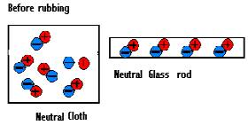
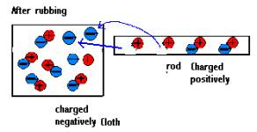

- Charged objects have electric fields around them.
- An electric field is defined as an area of influence around a charged object.
- Field lines are used as a means of providing a picture of an electric field; however these lines do not actually exist.
- Line density indicates the strength of the field and is proportional to the charge magnitude.

- Field around a point charge where the point is (i) negative, and (ii) positive. The field is defined as the direction a positive test particle would move.

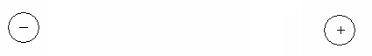

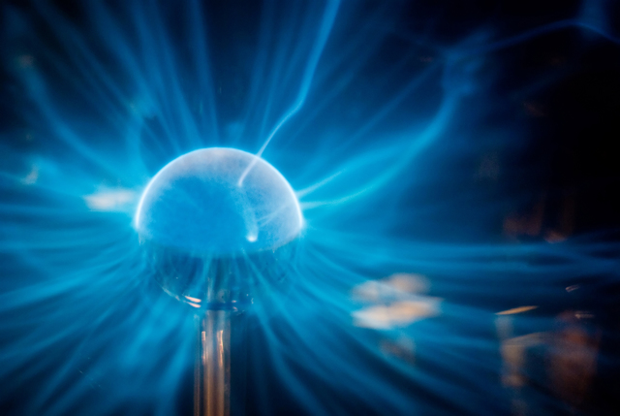


Charged plasma follows lines of the electric field around this Van der Graaff generator.
The girl's hair follows lines of electric field due to the fact that she became charged while sliding down the plastic slide.

- If a charged particle is brought close to another charged particle, their fields can influence each other.
- Like charges will produce a combined field that causes the charges to repel.
- Unlike charges will produce a combined field that causes the charges to attract.

- Field between two point charges; two different charges and both the same charge




- Field between a plate and a sphere where both the same charge and different charges.

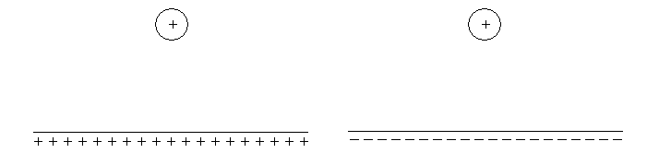
- Field between two plates, one positive and one negative.
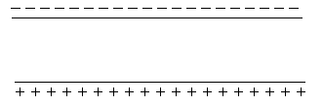

- Some important facts emerge when plotting lines of force:
- Lines of force NEVER cross.
- Lines of force are CONTINUOUS.
- Lines of force have a definite DIRECTION from positive to negative.
- Lines of force that are close together indicate a STRONG electric field.
- Lines of force that are farther apart indicate a WEAK electric field.

- The lines which make up a electricic field show the direction and intensity.

- To construct the field lines around charged particles, it is useful to consider the vector nature of the field at various points.
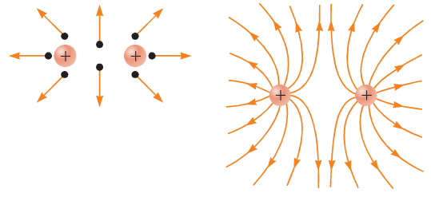

- Draw an electric field around the following situation.  -  +  + | - Identify the point charge in each of the following electric field diagrams.  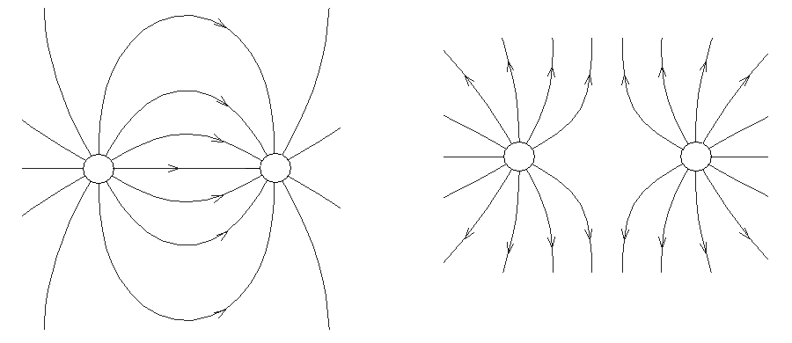
- Which is the positive plate in the following situation? | - Explain why the field lines around a positive charge are close together near the charge but are further apart at a distance from the charge.

- Two point charges are shown in the diagram below. Their relative charges are -2Q and +Q. On the diagram show the relative shape of the net electric field established around and between the point charges. You should draw at least 12 field lines on the diagram.

-2Q
+Q

PP 4.1 p 134-7 4.1 Review p 138 WSG 2.2 p52-3

A positively charged body placed in an electric field will experience a force in the direction of the field; the strength of the electric field is defined as the force per unit charge
This includes applying the relationship

Electric Field Strength (Electric Field Intensity)
- A charged particle will have an electric field around it.
- If this charged particle is placed into an electric field the two fields will interact and create a force.
- The size of the force depends on the strength of the electric field (E) and the charge on the particle (q).

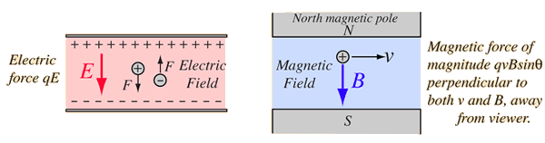
F = Eq

- The strength of an electric field (or electric field intensity) at any point in space can be determined by calculating the force per unit charge at that point.

where: E = electric field strength (N C⁻¹)
F = force (N)
The direction of the electric field (E) indicates the direction that a force (F) would act on a positive charge. A negative charge would experience a force in the opposite direction to the field.
q = charge being moved (coulombs C)

Note: since $F= \frac{k q_{1}q_{2}}{r^{2}}$, and $E= \frac{F}{q}$ , $E= \frac{k q}{r^{2}}$

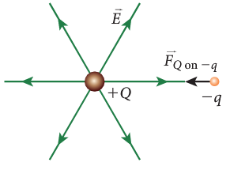
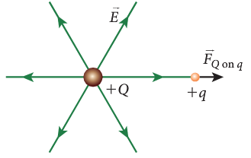

A large positive charge repels a small A large positive charge attracts a small
positive charge. negative charge.

- Example:
A point charge of 8.68 μC experiences a force of 5.44 x 10⁻³ N when it is placed into an electric field. Calculate the electric field strength at that point.

- A force of 3.10 x 10⁻⁹ N east acts on a charge at point P which is in an electric field of strength
6.20 x 10⁻³ N C⁻¹ west.
- Calculate the magnitude of the charge.

- Determine the sign of the charge and explain why.

- A charge of +5.00 μC is in an electric field of strength 1.60 x 10⁻³ N C⁻¹ north at point X. Calculate the force on the charge.

- NOTE: the charge on an electron is -1.6 x 10⁻¹⁹ C while a charge on a proton is +1.6 x 10⁻¹⁹ C.

When a charged body moves or is moved from one point to another in an electric field and its potential energy changes, work is done on the charge by the field
This includes applying the relationship

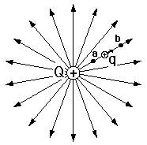
- Electric potential is the amount of potential energy a point charge has due to its position in an electric field.
- A point charge close to a charged sphere will be at a higher potential than one further away. a has a higher potential than b.

- Two points in an electric field can be at a different potential. There will be a potential difference (V) between them.

- To move charge q from b to a would require energy or work (W) to be put into it.
- If the charge q was released from a, it would move towards b.

- The amount of energy or work required to move a charge depends on the difference in potential between the two points and the size of the charge.

W = Vq

- Also, because q = It, therefore

W = Vq = VIt

- If in moving a charge of one coulomb from one place to another, one joule of work is done (or 1 joule of kinetic energy is gained), then the electrical potential energy difference between the two places is one volt. Hence,
where V = Potential energy in volts (V)
W = work done in joules (J)
q = charge in coulombs (C)

- Examples:
1. A 12V battery supplies 10.0 μC of charge to a toy car. What work is done in moving the charge?

2. A current of 10.0 mA flows across a potential difference of 2.00 x 10² V for 3.00 minutes. What work is done?

WSG 2.2 p54
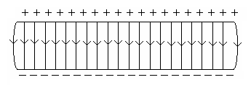
Electric Field Strength Between Parallel Plates
- We know as shown in the diagram to the right, that the field between two plates is uniform.

- When a charged particle moves from one plate to the other through the electric field, the force from one plate increases while the force from the other plate decreases.
+

- This way, the total force remains constant.

- One way to set up a charge on each plate is shown below. Within this pair of plates an electric field is set up and work is done on a free moving electron to move it from one place to other.

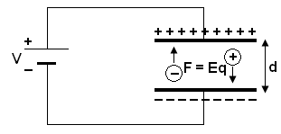

- The work done = force x distance
W = Fs
but F = Eq so W = Eqd
Since W = Vq,
Vq = Eqd “q” will cancel out so
V = Ed or more commonly
where: E = Electric field strength (V m⁻¹
V = voltage between plates (V)
d = distance between plates (m)

- Combining the equations for electric fields and it can therefore be seen that the units for electric fields, N C⁻¹ and V m⁻¹ must be equivalent.

E =

- Two charged parallel plates are placed 10.0 cm apart and a potential difference of 240 V between them.
- Determine the electric field strength between the plates.

- If an electron is located halfway between the plates, what force would it experience?

- An electric field intensity of 8.30 x 10⁴ V m⁻¹ is found between two charged parallel plates which are 6.50 mm apart.
- Calculate the potential difference across the plates.

- Calculate the gain in kinetic energy of an electron as it moves from the negative plate to the positive plate.

- Assuming that the electron was initially at rest on the plate, calculate its final velocity.

- A charge of -2.40 uC is in a electric field of strength 8.00 x 10⁻³ N C⁻¹ west at point X. Calculate the force on the charge.

- Two charged parallel plates are 10.2 cm apart. An electric field intensity of 3.50 x 10⁵ V m⁻¹ is set up between the plates.
- Calculate the potential difference between the plates.

- Calculate the gain in kinetic energy of a proton as it moves from the negative plate to the positive plate.

- Calculate the final velocity of the proton if it was initially at rest.

PP 4.3 p 144-6 4.3 Review p 147 Chapter review p 148-9
WSG 2.2 p 56-58
The direction of conventional current is that in which the flow of positive charges takes place, while the electron flow is in the opposite direction

ELECTRIC CURRENT
- When charges move, they form an electric current. We can say that current is the rate of transfer of charge or the rate of flow of electrons or the rate of flow of charge.

- The unit of electric current is the ampere (A). If one coulomb of electric charge passes any one point in one second, it is said to form one ampere (A) of current.
- Mathematically, we can express this as where q = charge in coulombs (C)
I = current in amperes (A)
t = time in seconds (s)

Conventional Current And Electron Current

- Prior to 1897 when Thomson discovered electrons, scientists believed that electricity was a flow of ‘electric fluid’ which moved from a positive potential to a negative potential (flow of positive charge).
- By the time they realized that negative electrons flowed in the opposite direction, the idea of a positive flow of charge was too firmly built into the theory of electricity.
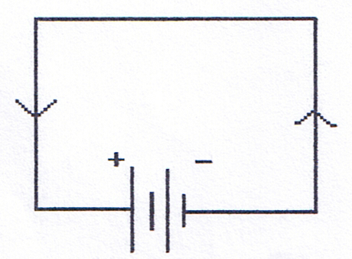
- As current is the rate of transfer of charge, we now call the flow of positive charge conventional current and the actual flow of electrons, electron current.
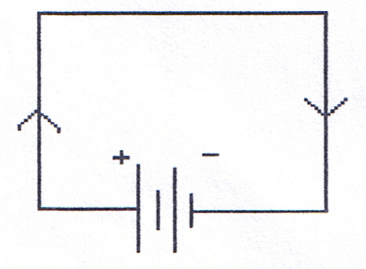

Conventional Current:  Defined as being in the direction of charge transfer. When we refer to the direction of current in a circuit we are referring to conventional current. |  | Electron Current:  Electrons flow from a region of higher potential to lower potential, in other words, from negative to positive. Electron current is used to describe the actual movement of electrons.

Direct Current and Alternating Current

- In direct current, or DC circuits, the flow of electricity is only one way. The polarity of the potential difference stays constant, in other words, the positive terminal is always positive and the negative terminal always negative.
- In alternating current, or AC circuits, the polarity of the potential difference can change in a regular way, so that the charge first flows in one direction, then in the other.
- The Australian mains electricity supply is 240 V AC, changing polarity 50 times a second; that is a frequency of 50 Hertz.

WSG 2.2 p55 Q’s 1-11 p87-8

Current-carrying wires are surrounded by magnetic fields; these fields are utilised in solenoids and electromagnets

Electromagnetism – Magnetism from Electric Currents:

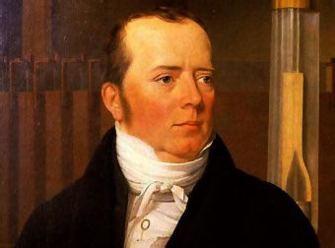
Magnetic Fields and Currents
- Hans Christian Oersted predicted in 1813 that a connection would be found between electricity and magnetism.
- In 1819 he placed a compass near a current-carrying wire and observed that the compass needle was deflected.
- This discovery demonstrated that electric currents produce magnetic fields.

- A magnetic field is a region around a magnetic material or a moving electric charge within which the force of magnetism acts.
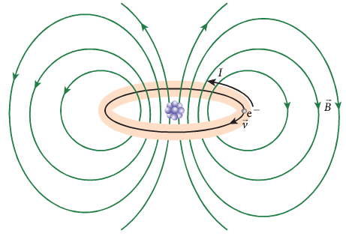
- Any moving charged particle can create a magnetic field.
- Electrons moving in atoms create magnetic field.
- Most atoms are not magnetic because their magnetic fields cancel out.
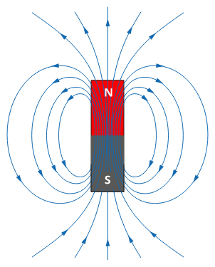
- Some material like iron, cobalt and nickel can be magnetised.
The field lines around and inside a bar magnet. The lines show the direction of the force on an (imaginary) single north pole.
The direction is defined as the direction that a test compass would point – N to S.

- When magnetic fields are bought close together, the fields will interact. If the fields are in the same direction, they will attract. If they in opposite directions, they will repel.
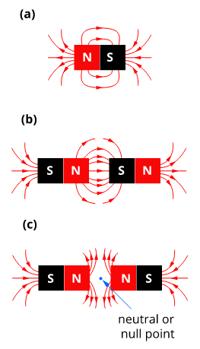


WSG 2.3 p59-61

- When Oersted passed a current though a wire he found that it created a magnetic field.
- The magnetic field lines form concentric circles around the wire.
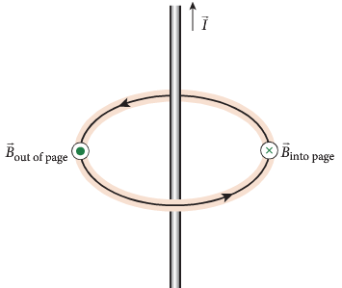
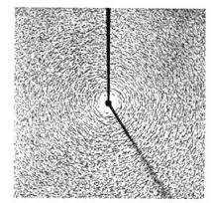
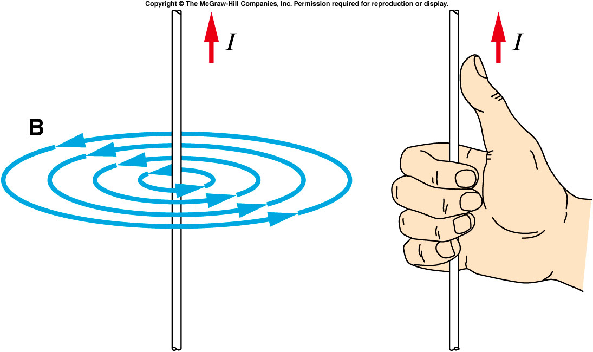

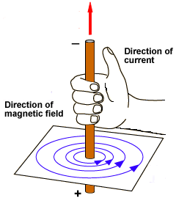
Direction of the field or current can be determined by the Right Hand Grip Rule:
- If a straight conductor is held in the right hand with thumb pointing in the direction of conventional current (positive to negative) the curled fingers show direction of circular fields.

- Direction of current can be drawn as follows:
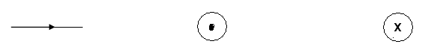
Arrow shows direction parallel to page |  | Shows current coming out of page, arrow towards you |  | Shows current going into page, arrow away from you.

- Determine the direction of the field in the following straight line conductors.

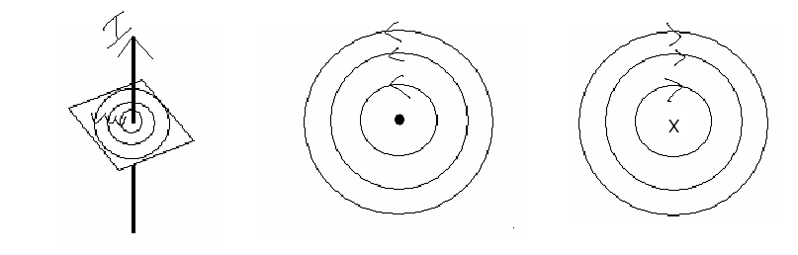

Applications of Electromagnetic Principles:
- Electromagnets have had a significant technological impact and have lead to numerous applications. For example, electric motors, stereos, radios, T.V., electrical meters, oscilloscopes, computers, dynamos, generators, alternators and of course, the large electromagnets used for cleaning up scrap yards and industry.
Fields Around A Coiled Wire

- A straight wire produces a circular magnetic field that quickly weakens as you move away from the wire - not a very useful field for practical purposes.

- In a single loop, the magnetic field is magnified in the centre of the loop but is still not strong enough.
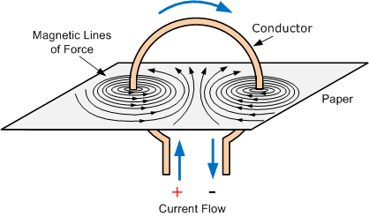

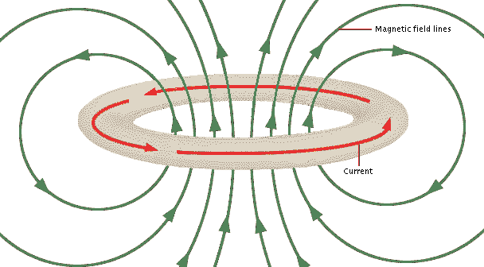

- By twisting the wire into a large number of helical coils (spirals) a magnetic field of a permanent magnet can be simulated.
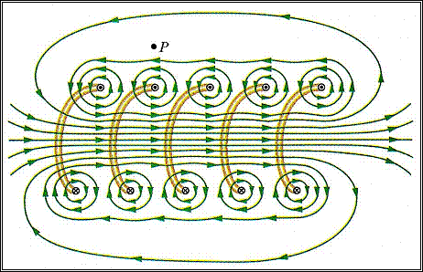
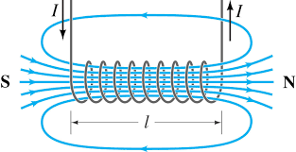

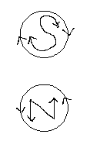
- This electromagnet (or solenoid) is strong enough to replace permanent magnets and as the number of coils is increased, a very powerful magnet can be created that has the advantage of being able to be switched off.

- To determine the north and south ends of a solenoid,
a. “stand” at one end e.g. the left.
b. determine if the direction of current is clockwise or anti-clockwise
c. clockwise - south
anti-clockwise - north
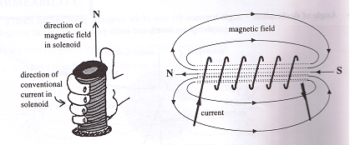
d. Alternatively, use the Right Hand Grip Rule for Solenoids (conventional current).

- The magnetic field inside a solenoid can be intensified by placing an iron core inside the solenoid.
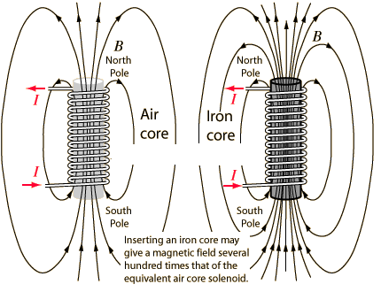

WSG 2.3 p62

The strength of the magnetic field produced by a current is a measure of the magnetic flux density
This includes applying the relationship

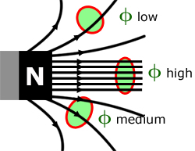
- Magnetic flux (Φ) is a measure of the amount of magnetic field passing through a specified area in a magnetic field perpendicular to that surface.
- Magnetic flux density (B) is a measure of the number of flux lines in an area.
- A high flux density, like at the poles of a magnet, means a large number of flux lines in a certain area. This indicates a stronger magnetic field.
- A low flux density, like at the sides of a magnet, means a small number of flux lines in a certain area. This indicates a weaker magnetic field.

- As seen in the previous section, a current flowing through a conductor produces a magnetic field around the conductor. The lines of flux are concentric circles around the wire.
- The strength of the magnetic field at any point relates to the magnetic flux density, B.
- The magnetic flux density depends on three factors:
  - The current, I. Higher current produces more flux lines and larger flux density.
  - The distance from the wire, r. The further away from the wire the weaker the flux density.
  - The medium around the wire. μ₀ is called the permeability of free space and has a value of
4π x 10⁻⁷ T m A⁻¹.
  - The permeability of a metal can be up to 200 000 times higher.
- Calculate the magnetic flux density at a point 1.27 cm from the centre of wire that has a current of 5.00 A flowing through it.

- A magnetic field strength, B, of 1.5×10⁻⁵ T is measured at a distance of 3.0 cm away from a long, straight wire. Calculate the current flowing through the wire that would create this magnetic field.

- A wire is conducting a DC current of 1.50 A. At point X a magnetic flux density of 3.86 x 10⁻⁶ T is detected. Calculate the distance between the current carrying wire and point X. You can ignore the effects of the Earth’s magnetic field in this question.
Point X, B = 3.86 μT
Distance
1.50 A

PP 5.1 p 152-60 5.1 Review p 161-2 WSG 2.3 p62-3

Magnets, magnetic materials, moving charges and current-carrying wires experience a force in a magnetic field when they cut flux lines; this force is utilised in DC electric motors and particle accelerators
This includes applying the relationships

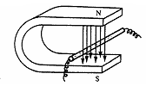
CURRENT, FIELD AND FORCE

- If a current-carrying wire is placed in a magnetic field as shown below, it can easily be demonstrated that a force is exerted on the wire.
- This force causes the wire to move either into or out of the horsesho magnet, depending on the direction of the current in the wire.

- What do you think produced the force that caused the wire to move?

Magnetic field moves from high to low = FORCE.
Magnetic fields combine.
Magnetic field of magnets.
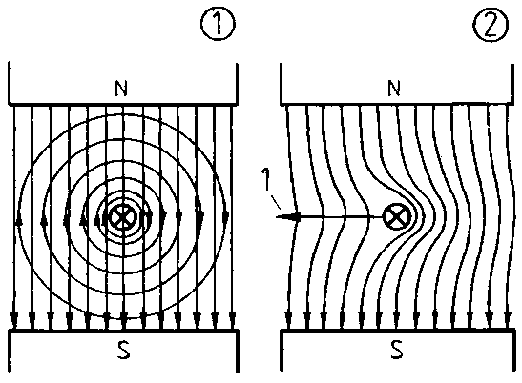
Current carrying wire produces a magnetic field.

F

X

Right Hand Palm Rule
The direction that the wire moves can be found using the Right Hand Palm Rule
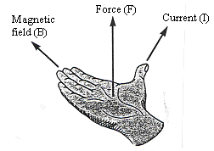
- Thumb is current direction (conventional)
- Fingers point in direction of field (North to South)
- Palm points in direction of force.

- In your own words, fully explain why a force is created?

Describing direction
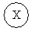


top of bottom of right left into page out of page
page page

- For each of the following situations draw in the direction of the force.

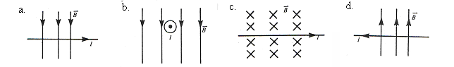

- Draw in the following fields and find the direction of the field.

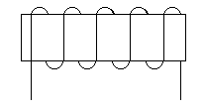
- Conventional current.

X


- Electron current
.

- Find the direction of the third component (I, B or F) assuming conventional current.
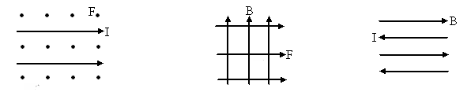

CALCULATING THE STRENGTH OF THE FORCE.

- Three factors are important in calculating the force on the wire. What are they?

- Logically, it should be realized that the force would be affected by the strength of the magnetic field, the size of the current, and how much wire is actually in the magnetic field. In fact,

F = BI where F = force in newtons (N)
I = current in amperes (A)
B = strength of magnetic flux density in teslas (T)
= length of conductor in magnetic field in metres (m)

- Santa's house sits at a point that can be considered the Earth's south magnetic pole. Assuming the strength of the Earth's magnetic field at this point is 5.0 x10⁻⁵ T, calculate the magnetic force and its direction on a 2.0 m length of wire carrying a current of 10.0 A vertically up the wall of Santa's house and a 2.0 m length of wire carrying a current of 10.0 A running horizontally right-left across Santa's house.

- An electric motor in a hair dryer needs a current of 10.0 A to operate. If the side of the armature between poles of the magnet is 120 mm long, what force acts on each wire around the armature when it is perpendicular to the magnetic field of strength 2.00 T.

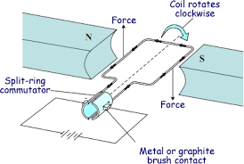

PP 5.3 p 169-73

WSG 2.4 p66

Force On A Charged Particle Moving In A Magnetic Field.

- A free moving charged particle in a magnetic field will experience a force and be deflected.

- It experiences a force as the movement of the charged particles creates its own magnetic field and this magnetic field interacts with the existing magnetic field producing a force that can change the direction of the charged particle.

- The amount of deflection depends upon the magnitude of the force. The direction of the force can be determined by the right hand rule for positive charges.

For a positively charged particle at right angles to the field:

- fingers – point direction of field
- thumb – diction of velocity of positive charge (note: for a negatively charged particle the thumb points in the opposite direction to motion or use your left hand)
- palm – direction of force

- For negatively charged particles such as an electron, use your left hand.

Mathematical Relationship

F = Bqv where F = force on charge in newtons (N)
q = charge in coulombs (C)
v = velocity of charge in metres per second (m s⁻¹)
B = magnetic flux density in teslas (T)
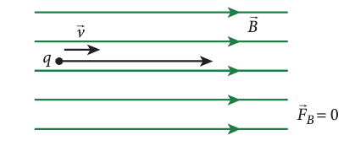
- It should be noted that when the charge is travelling parallel to the field, no force will be acting on it.

- There must be a component of the velocity cutting the field in order to produce a force.

- While a charged particle remains in the field, the force, and therefore the acceleration, on the charged particle will be perpendicular to the motion.

- This results in the particle undergoing uniform circular motion. If the charged particle is introduced into the magnetic field at an angle, it will spiral in a helix, rather than a flat cirlcle.
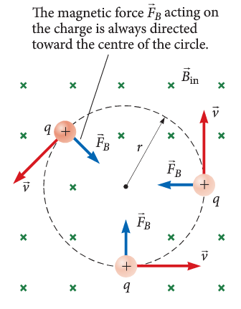

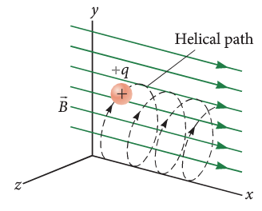

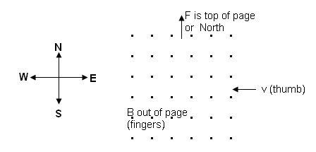
- A beam of positively charged helium ions (He⁺) travelling at 6.00 x 10⁵ m s⁻¹ moves from east to west into a magnetic field of 2.50 x 10⁻² T which is directed vertically upwards. Find the magnitude and direction of the force acting on each ion.

- In various pieces of scientific equipment, such as the Synchrotron or the Mass Spectrometer, charged particles move through magnetic fields and undergo circular motion.
- It is often useful to work out values like velocity, radius of the path or mass of the particle.

$$F_{c}=F_{m}$$

$$\frac{mv^{2}}{r}=Bqv$$

$$v= \frac{Bqr}{m} or r= \frac{vm}{Bq} or m= \frac{Bqr}{v}$$

- An electron is circulating inside the ring of a Synchrotron with an orbital radius of 125 m. The electron has a velocity of 1.50 x 10⁸ ms⁻¹.
  - Calculate the strength of the magnetic field required to keep the electron in orbit.

  - Calculate the period of the electron’s orbit.

PP 5.2 p 163-6 5.2 Review p 167-8
WSG 2.4 p67-71 Q’s 20-30 91-4

The force due to a current in a magnetic field in a DC electric motor produces a torque on the coil in the motor
This includes applying the relationship

Motor Effect

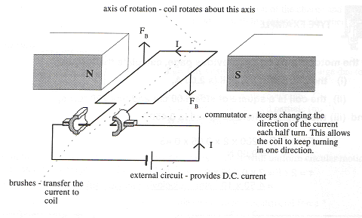
- An electric motor works as follows:
- A coil of wire is placed between two permanent magnets.
- Electricity is passed through the wires.
- The electricity in the wires causes a magnetic field to form.
- The magnetic field of the permanent magnets interacts with the magnetic field of the coil.
- The two magnetic fields cause the coil to turn as shown below. If the coil is attached to a rod, then the rod will also turn and this can be used to run an electric motor.
- The force on each side of the coil perpendicular to the field is determined by:

F = BI where F = force on each side of the coil (N)
n = the number of coils
I = the current flowing in the coil (A)
= length of conductor perpendicular to magnetic field (m)
B = the magnetic field intensity.

- The force can be increased by having a larger number of coils

F = nBI where n = the number of coils

Fields around coil in a motor
- When a coil is placed within a magnetic field and a current allowed to run through the coil, the interaction of the two fields causes a force to be produced that produces movement. The force is a maximum when the coil is parallel to the magnetic field.

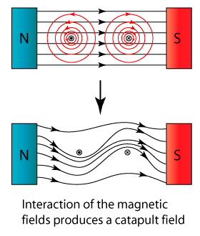
- Where the magnetic field of the permanent magnet is in the same direction as the magnetic field produced in the current carrying coil, then the field strength is increased and a force is applied to the wire that tries to move it away from the higher field strength.
F
F




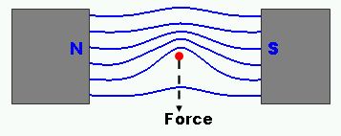
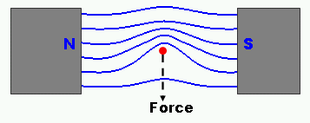
- When the coil is perpendicular to the field, the force still tries to move it perpendicular to the magnetic field, but the axle of the coil prevent movement.
F
F

X

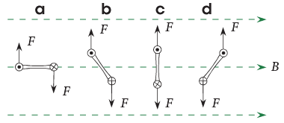
Force will be constant.
However, torque (the turning effect) will reduce from (a) to be 0 at (c).
The torque reverses at (d) so a system is required to change the direction of the current at (c).
- To keep the coil rotating, the direction of the force needs to change. This is achieved by using a split ring commutator which changes the direction of the current in the coil and hence the direction of the force.
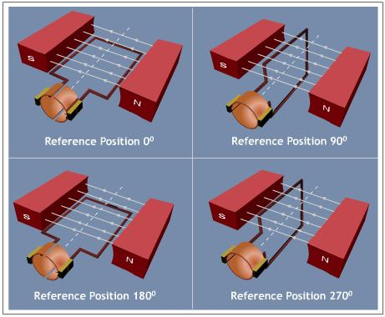
B
I
A
I
DC current in – only travels in one direction.

- As the coil reaches the vertical position, the current momentarily stops due to the gap in the split ring commutator. The momentum of the coil carries it past the vertical position.


I
I
B
A

- Current now flows into the opposite side of the coil, the force changes direction and the coil continues to spin.

I
A
B


- Again, when the coil reaches the vertical position the split ring commutator changes the direction of the coil and the coil continues to spin.
B
A
I

Torque in Current Loops in a Magnetic Field
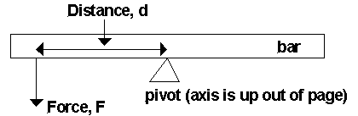
- A torque is defined as the turning moment of a force.
- The torque about an axis of rotation is the product of the perpendicular distance of the axis from the line of action of the force and the component of the force in the plane perpendicular to the axis.

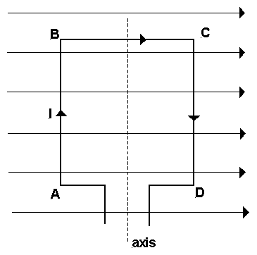
- For this situation, the torque τ on the bar about the pivot is:
τ = F r

- Since the force on one side of the coil is given by F = BI
τ = BIr

- Consider a rectangular coil of wire carrying a current I and sitting in a magnetic field of flux density B, with its plane parallel to the field direction, as shown below:

- For this coil:
- force on AB is down into the page,
- force on CD is up out of the page,

- Therefore, the coil turns under the action of an applied net torque, with CD coming up out of the page and AB going down into the page. The coil spins in an anti-clockwise direction about the axis – looking from below.

- Once the coil has passed through the position where its plane is perpendicular to the field direction, the direction of the current is changed using a split ring commutator.
- This makes the force change direction and ensures that the coil continues to turn ACW.

- The turning effect or torque can be determined as follows:

τ = 2 F r⊥ where τ = torque (Nm)
F = force on each side of the coil (N)
r⊥ = perpendicular distance from axis to rotation to edge of coil (m)

- The 2 is there because equal forces are provided by both sides of the coil.

  - A motor with a square coil of sides 5.00 cm and 200 turns, has a current of 2.00 A passing through it. If the magnetic field of the magnets is 0.450 T determine the torque of the motor.

- To improve the turning effect of a motor
- Use a soft iron core in the coil (increases overall magnetic field of coil)
- Use stronger magnets
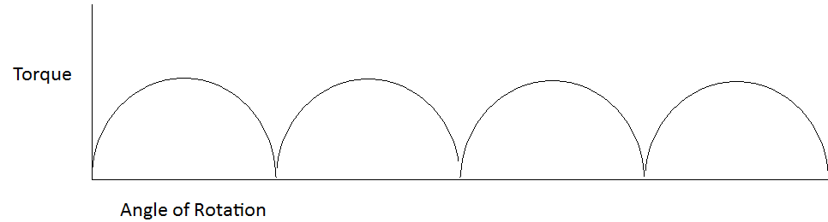
- Use more coils
- Have a larger current

- A graph of the torque produced in the coil is shown.

PP 5.3 p 174-6 5.3 Review p 177-8 Chapter review p 179-180
WSG 2.5 p71-3 Q’s 31-34 p94-5
Review – answers p 29
  - Draw the field around the following, bar magnets with a current carrying wire between them. The magnets have opposite poles facing each other.

N S
N S
Xx
X

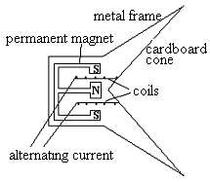
  - The diagram right shows a speaker.

  - Why does the speaker use alternating current?

  - What happens when a current initially enters the coil?

  - Explain, using the ideas above, how the speaker works.

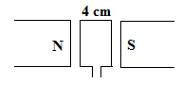
- A motor with a coil of 120 turns has a permanent magnet producing a magnetic field of 0.05 T. Using the diagram below, determine the force on one side of the motor if the lengths of the sides of the motor are 4 cm and 6 cm and a current of 0.2 A.

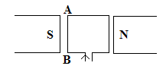
- A square coil of wire of side length 3.5 cm is placed in a magnetic field of 0.6 T as shown below. If a current of 2.3 A runs through the coil and the coil have 250 turns,

- in which direction will the side AB move?
- what is the force on side AB?

- what is the torque on the motor?

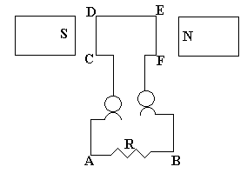
- Look at the diagram of the motor:

Side CD is moving into the page.
- Which way will the current flow through R?
A to B or B to A
- The potential difference is 3.40 V and the resistance 12 ohms, determine the minimum power to rotate the coil.

- Calculate the torque on a square motor which has 500 turns, if the length of the sides between the 0.80T permanent magnetic field is 23.0 cm and the current in the motor is 2.1 A?

Review
  - Draw the field
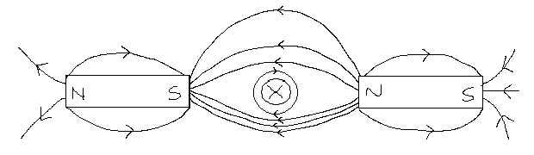

- Why does the speaker use alternating current?
Speaker needs to move in and out to produce sound. Alternating current results in changing direction of current so change in coil movement.
- What happens when a current initially enters the coil?
Current in coil produces magnetic field, this magnetic field interacts with permanent magnet creating a force and coil moves either in or out
- Explain, using the ideas above, how the speaker works.
Electrical signal from initial sound put into speaker. Magnetic field from current interacts with field from permanent magnetic. Changes in current changes magnetic field strength and direction, cone vibrates producing sound waves.
- A motor with a coil of 120 turns
= 0.06 x 120 = 7.2 m F = BI
= 0.05 x 0.2 x 7.2
F = 0.072 N
- in which direction will the side AB move? out of page
- what is the force on side AB?
F = BI
= 0.6 x 2.3 x 8.75 or = 0.6 x 2.3 x 0.035 x 250
F = 12.075
F = 12.1 N
- what is the torque on the motor?

r⊥ = τ = 2Fr⊥
= 2 x 12.075 x 0.0175
τ = 0.423 Nm
- Which way will the current flow through R?
A to B or B to A
- The potential difference is 3.40 V and the resistance 12 ohms, determine the minimum power to rotate the coil.
V = 3.4 V
R = 12 Ω P = 0.92 W

P = VI
I = V / R
P = VV / R
P = V² / R
- Calculate the torque on a square motor which has 500 turns, if the length of the sides between the 0.80T permanent magnetic field is 23.0 cm and the current in the motor is 2.1 A?
turns = 500 τ = 2Fr⊥
length = 0.23 = 2(B I)r⊥
= 2 (0.8 x 2.1 x (500 x 0.23) x 0.115)
τ = 44.4 Nm
Simple and complex motors
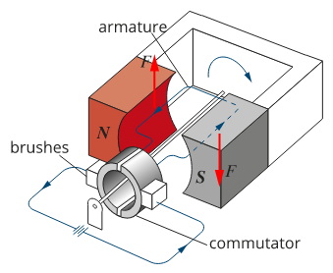
The main parts of a simple electric motor.

A typical universal electric motor, showing the main components. Some motors would have additional stator coils. The commutator feeds current to the armature coils in the position where most torque will be experienced. This type of motor will operate on either DC or AC power.

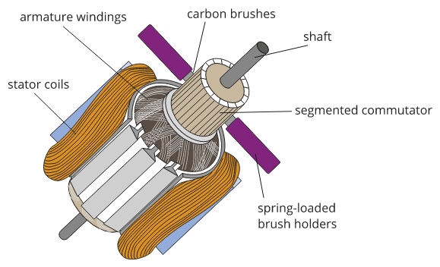
Split ring commutator Slip ring commutator
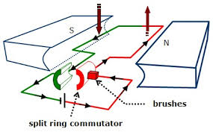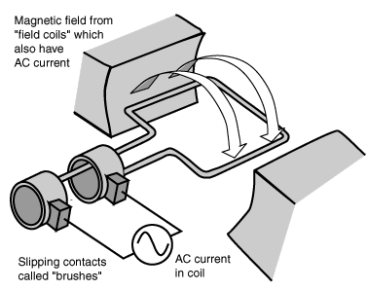
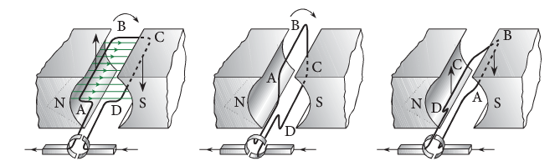

- Explain the function of the brushes and the function of the commutator.

Magnetic flux is defined in terms of magnetic flux density and area
This includes applying the relationship

MAGNETIC FLUX and MAGNETIC FLUX DENSITY

- To fully describe a magnetic field at a point, both a direction and a magnitude (or strength) must be given.
- This is known as the magnetic flux density, represented by the letter B and has the unit tesla (T).
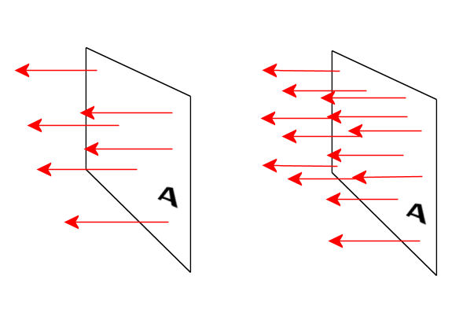
- It is often more useful to know the total effect of a magnetic field, known as the magnetic flux, φ, the unit of magnetic flux is the weber (Wb).

φ = BA where φ = magnetic flux (Wb)
B = magnetic flux density (T)
A = area (m²)

Magnetic Flux Density
- Often called Magnetic Field Strength
- Symbol is B
- Has the unit of Teslas, T.
- For permanent magnets, the value doesn’t change.
- For electromagnets, the value can be changed by changing the size of current in the wires surrounding the soft iron bar.

Magnetic Flux
- Symbol φ
- Actual formula is φ = BA cos θ
- Where B is the component of magnetic field perpendicular to the face of the coil. When the face is perpendicular to the field, θ = 90⁰ so φ = BA (will only get 90⁰ in ATAR examination).
- Measured in units called webers, Wb.

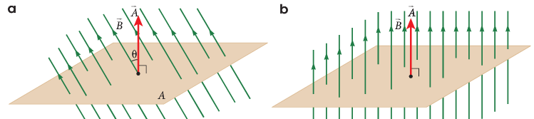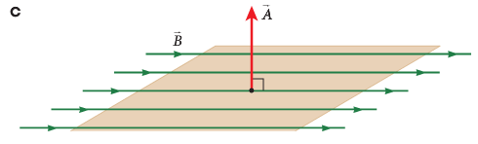
φ = BA cos θ φ = BA φ = 0

- Looking at coil down from the top:

Coil parallel to Coil at 45⁰ to Coil at 90⁰
Field, φ = zero field, φ = BA cos 45 field, φ = BA

- This can now explain the graph of magnetic flux, φ versus time.
For a coil starting as shown and rotating clockwise 360⁰
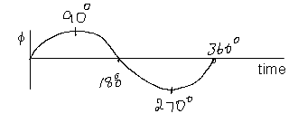
NOTE:
Maximum flux change over ¼ of a turn

⊕

  - What is the total magnetic flux passing through an area of 2.50 x 10⁻⁴ m² if the magnetic flux density is 5.00 x 10⁻⁴ T?

NP 124-7
WSG 2.3 p64-5 Q’s 12-19 p88-90

  - A coil in an electric motor is at an angle of 40⁰ to the horizontal. If the field strength is 5.00 x 10⁻⁴ T, and the coil has an area of 4.00 x 10⁻³ m², what is the magnetic flux passing through the coil?

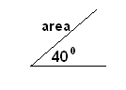

  - Find the total flux through an area of 0.060 m² at right angles to a uniform field of magnetic flux density 1.75 T. (0.105 Wb)

  - If 6.089 x 10⁻⁴ Wb threads an area of 165 mm², what is the magnetic flux density?
(3.69 T)

  - It a certain place on the earth’s surface, the horizontal component of the earth’s magnetic field is 4.50 X 10⁻⁵ T. A wire oriented at right angles to this horizontal component is moving vertically so it cuts the field at right angles with a speed of 25.0 ms⁻¹. If the wire is 12.0 m long, what is the magnetic flux cut per second?
(1.35 x 10⁻² Wb s⁻¹)

  - The flux density in a cylindrical iron rod of diameter 2.00 cm is 2.10 T. What is the total magnetic flux inside the rod? (6.60 x 10⁻⁴ Wb)

An induced emf is produced by the relative motion of a straight conductor in a magnetic field when the conductor cuts flux lines
This includes applying the relationship
where

FARADAY’ S DISCOVERY

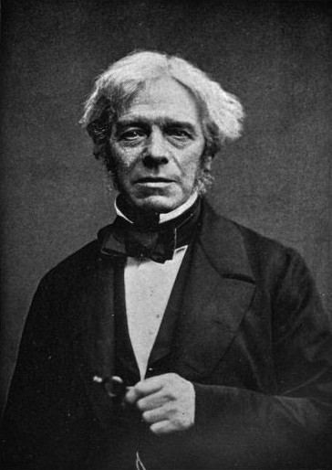
- Faraday found that when a wire is moved through a magnetic field, a current is generated in the wire. If the wire moves up through the field, the current moves in one direction, if moved down, the current moves in the other direction.

- For a current to be produced either the conductor can move through the field or the field can move past a conductor. In both cases, it is the motion between wire and magnetic field that produces the current.

- Whenever the magnetic flux lines are cut by a conductor that is part of a closed loop, a current is induced in the loop. This is called electromagnetic induction.

- Induced means to cause something to occur.

- The reason for the induced current can be explained in this diagram.
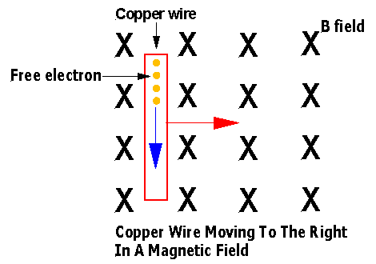
- Consider the electrons in the wire. As they are contained inside the wire and the wire is moving to the right, the electrons are moving the right.

- Since the electrons are now moving through a magnetic field and they are charged, they will experience a force. Using the LH rule for electrons, they will experience a force downwards.

- The top of the wire will become positive and the bottom will be come negative – a potential difference is created.
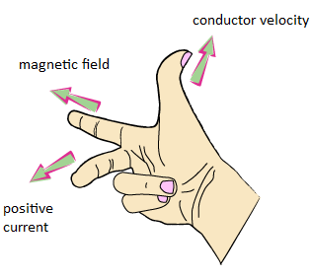
- Once the wire stops moving, the induced current stops.

- The difference in potential is the induced emf (electro-motive force). The emf, measured in volts, depends on the magnetic flux density (B) the length of the wire in the field () and the velocity of the wire in the field (v). If B, and v are mutually perpendicular,
emf = Bv

  - What emf is induced between the ends of a 25.0 cm long rod that is moving perpendicular to a magnetic field of 350 mT at 5.00 ms⁻¹?

  - What would the induced EMF be across the centre to tip of a horizontally rotating fan blade 1.2m long, if it is moving at 125 rpm in a vertical upward magnetic field (at the south pole) of
0.45 x 10⁻⁴T? (Hint: determine the average blade velocity along its length)

PP 6.1 p 182-6 6.1 Review p 186 WSG 2.6 p73-4
- a changing magnetic flux induces a potential difference; this process of electromagnetic induction is used in step-up and step-down transformers, DC and AC generators
This includes applying the relationships

- Faraday’s Law of induction states that the magnitude of the induced emf in a circuit is directly proportional to the rate at which the flux through the circuit (in the coil) is changing, this changing field produces the induced emf
NOTE:
Φ = BA
The sign is negative due to opposite
direction of induced current.

Where: N = number of turns of coil
(φ₂ - φ₁) = number of flux lines cut (also called flux linkage) in webers (Wb)
(always larger value minus smaller value)
t = time in seconds

  - A coil of 600 turns is threaded by a flux of 800 mWb. If the flux is then reduced to 200 mWb in 1.8 ms, what is the average emf induced in the coil?

  - A rectangular loop 5.0cm by 3.5cm consisting of 200 turns is immersed in a magnetic field of 0.25T. What average EMF is generated if the plane of the loop moves from parallel to 90⁰ to the field direction in 0.015 seconds?

- The formula for induced emf can be written in a number of ways. Read the question, determine what information is given, then use the appropriate formula.

- The above formulae are used to calculate the average emf induced over the time that the flux is changing.
PP 6.2 p 187-91 6.2 Review p 192 WSG 2.6 p75
Conservation of energy, expressed as Lenz’s Law of electromagnetic induction, is used to determine the direction of induced current

Introducing Lenz’s Law
- When electrical energy is created by a conductor moving through a magnetic field the energy created must come from somewhere.
- The energy comes as a result of the conductor slowing down. E_{K} E_{E}.
- This is known as magnetic braking.
- As the conductor moves through the magnetic field it experiences a force that opposes its motion, thus slowing it down. This is explained in Lenz’s Law.

- The direction of an induced current is such as to always oppose the change that is producing it.

- When a conductor moves through a magnetic field, current is INDUCED (or created) in the conductor.

- This current then creates a magnetic field. This magnetic field is in the opposite direction to the original magnetic field. (This makes sense because if they were in the same direction then they would continually reinforces each other ad infinitum thus obtaining unlimited energy for very limited expenditure.)

  - A wire is being moved through a magnetic field as shown.

X X X X X Consider a positive particle inside the wire.
X X X X X Indicate the direction it will move.
X X X X X
+
X X X X X Using X’s and ·’s indicate the magnetic field
X X X X X produced by the positive particle.

Superimpose this magnetic field on the original one.

  - Explain what effect this induced magnetic field has on the original field.

- This effect is known as Lenz’s Law and shows why Faraday’s equation is written with a negative sign:

- An induced EMF (or current) will only be induced when the magnetic field is CHANGING or when flux lines are being cut.

Other situations where currents are induced
Consider a positive particle in the wire in the coil.

Draw the ‘effective’ direction of movement of the positive particle.

- A magnet moving into or out of a loop of wire.
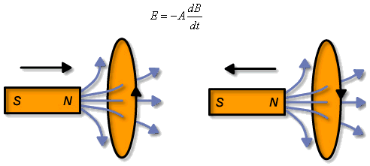
+

  - Which way will the positive particle move?

  - Explain this in terms of Lenz’s Law.

- A magnet moving in or out of a coil.
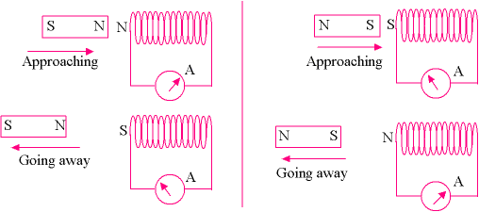
  - As a north pole approaches a coil of wire, the coil of wire will experience a changing magnetic field – the magnetic field is increasing.

. . . . N magnet
solenoid motion

mag field

  - A current will be induced in the coil.
  - This current will create a magnetic field.
  - The direction of the magnetic field created is in such a direction so as to oppose the original magnetic field.

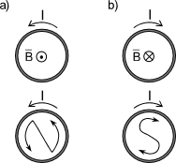
  - If a north pole approaches a coil, the coil will endeavour to produce a north pole – like poles repel.
  - This means the coil will have a current induced in an ANTICLOCKWISE direction.

- Using the same logic as above, explain what happens when a north pole is removed from a coil.

- Instead of using a permanent magnet to change the flux in the loop in the example just given, an electromagnet could be used.

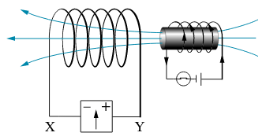
- What is the direction of the current induced in the solenoid when the electromagnet is: (a) switched on? (b) left on? (c) switched off?

- A coil of wire moving through a magnetic field.

X X X X X
X X X X X
X X X X X
X X X X X
X X X X X

  - In the first case, no changing magnetic field so no induced current.
  - As the coil enters the magnetic field a current is induced into it.
  - The magnetic field induced into the coil will be anticlockwise.

- A similar effect can be created by switching a magnetic field on and off near a coil.

- In order to induce a current, the following formula needs to be considered.
and Φ = BA

- Either, the strength of the magnetic field (B) need to change or, the area of the coil (A) needs to change.
  - Spin the coil in the magnetic field.
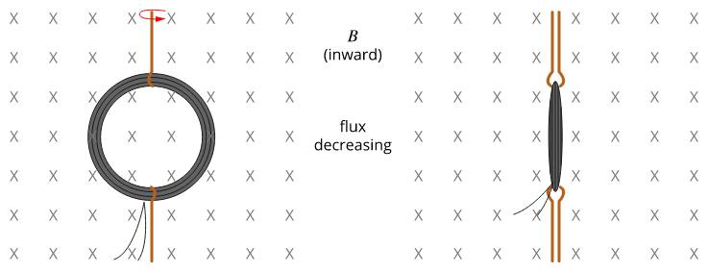
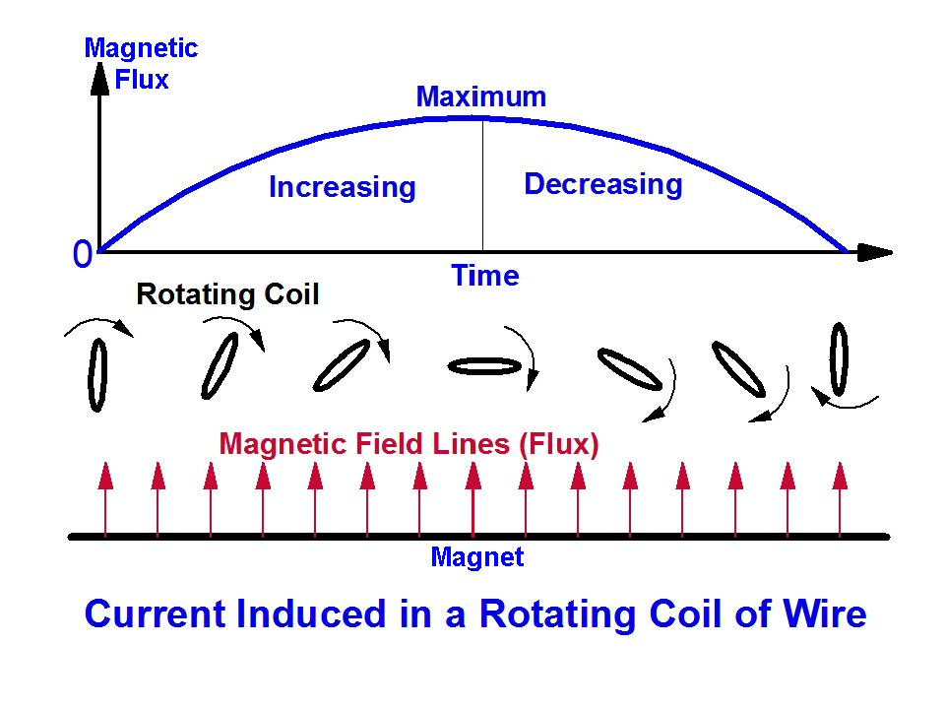
  - Change the shape of the coil in the magnetic field.
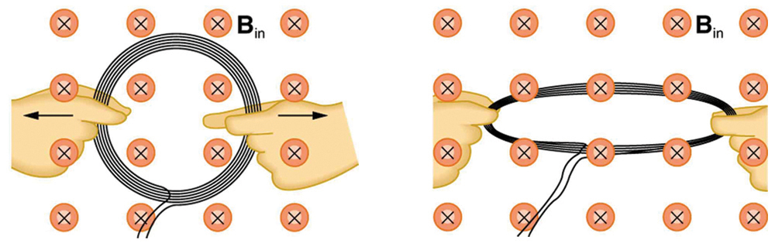

- When a magnet is dropped through a coil it will produce a current in one direction as it enters and in the opposite direction as it leaves.
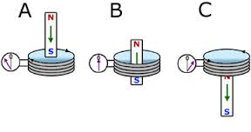
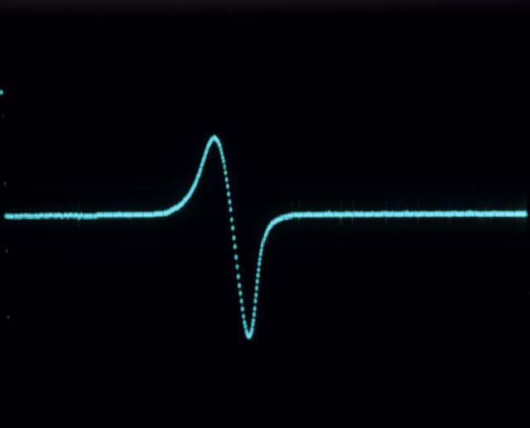
Oscilloscope trace from an electric coil, showing the voltage flowing in the coil as a magnet is dropped through it.

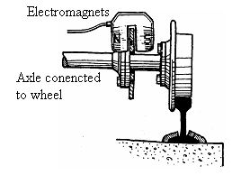
Applications Of Lenz’s Law

- Magnetic brakes on trains. When the brakes are applied, there is a magnetic field generated between electromagnets.
- As each section of the disc passes between the poles of the magnets it experiences a changing magnetic field.
- An emf is induced producing a current in the disc which then produces a magnetic field that opposes the direction of the other field causing the disc to slow and slows the train.
- This induced current can be stored and used to power the motor.
- Haulpak trucks use a similar system.

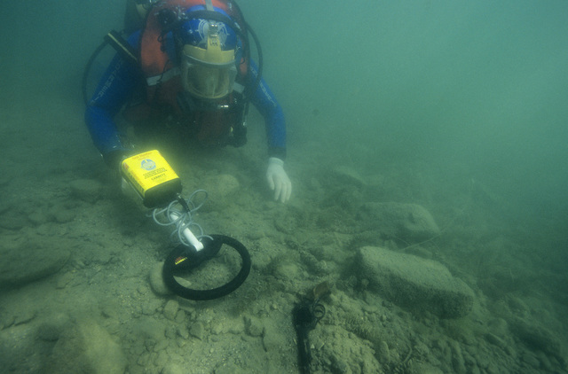
If metal is underneath the coil of the metal detector, the induced current will affect the original current. The direction of the induced current is predicted by using Lenz's law.

PP 6.3 p 193-200 6.3 Review p 2012 WSG 2.6 p75-8

Electric Generators
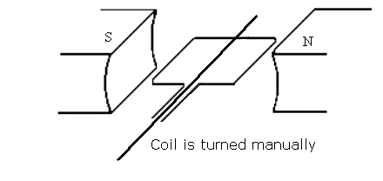
- An electric generators is the opposite of an electric motor in that a coil of wire is manually turned between two permanent magnets creating an electric current.

Generator Principle:
coil + magnet + movement = electricity

- A generator works as follows:
- A coil of wire is placed between two permanent magnets, as shown.
- The coil is turned manually (often by running water)
- As the coil moves through the field of the magnets it generates electricity in the coil.

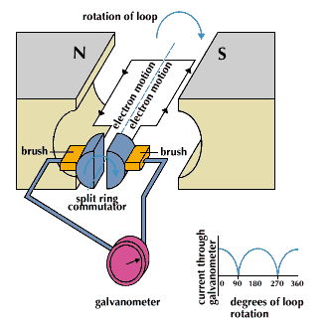

Commercial A.C. Generators have:

- Field magnets (stators)
- Many coils on armature
- Large fans for cooling
- Turbines ⇒ to enable armature to turn via external means (often steam).

- In Collie, coal is burnt to boil water and produce steam. The steam is used to turn large turbines that turn large coils between magnets producing the electricity used in Perth.
- Wind is also used as a source of kinetic energy.

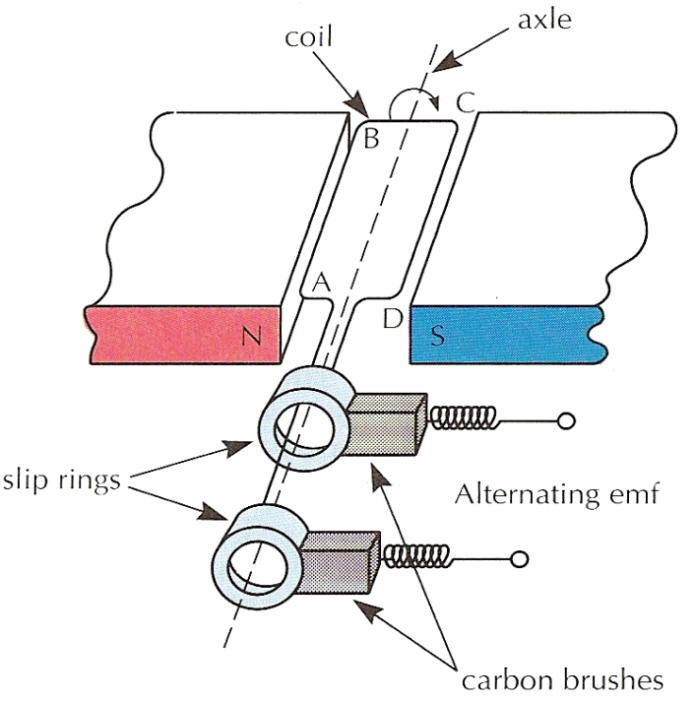
THEORY BEHIND GENERATORS

- This diagram shows a basic AC generator.
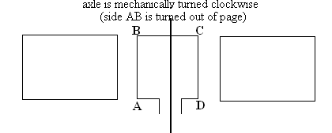

Permanent magnet

N S

- Generators produce alternating current by the following process:

Firstly:
- The coil is rotated clockwise (AB out of page) but by using Lenz’s Law, as AB moves upwards a downward magnetic force must be exerted on it to oppose this rotation.
- Using the motor principle, this downwards force will be exerted on conductor AB only if current is flowing from A to B as shown below.
- Similarly, the current in CD must flow from C to D.
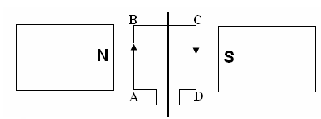
Use the right hand rule to verify the direction of the induced current.
Side AB moves out of page Side CD moves into page
Magnetic Force exerted into page Magnetic Force exerted out of page
Magnetic Field to right of page Magnetic Field to right of page
Current induced from A to B Current induced from C to D
Secondly:
- When the coil is in the vertical position, no flux lines are cut = no EMF.
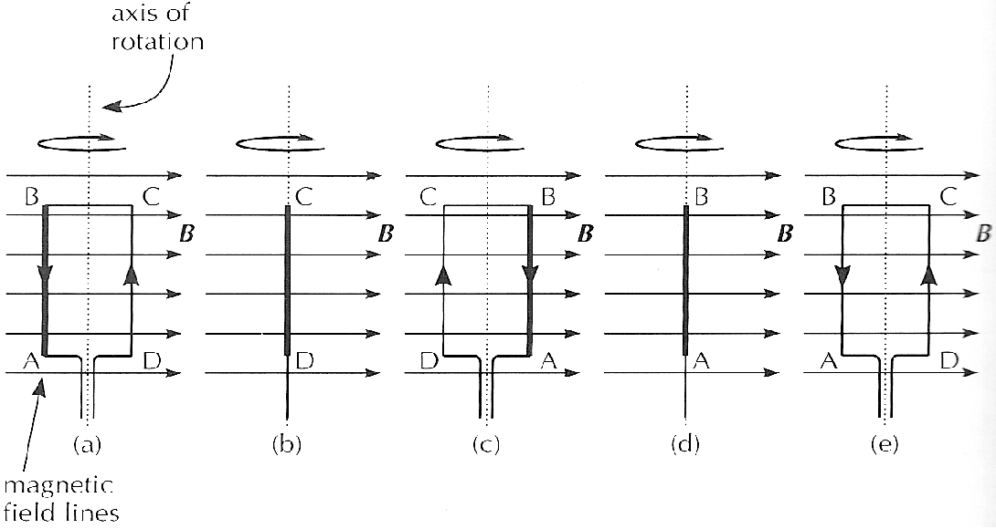

Thirdly:
- The coil is now turned 180⁰. Now the opposite occurs and the current runs from B to A and from D to C.
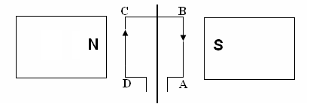
Side AB moves into page Side CD moves out of page
Magnetic Force exerted out of page Magnetic Force exerted into page
Magnetic Field to right of page Magnetic Field to right of page
Current induced from B to A Current induced from D to C

In other words, the current has reversed direction.

Fourthly:

- When the coil is in the vertical position, no flux lines are cut = no EMF.

Fifthly:
- This turning continues and produces an Alternating Current (AC).
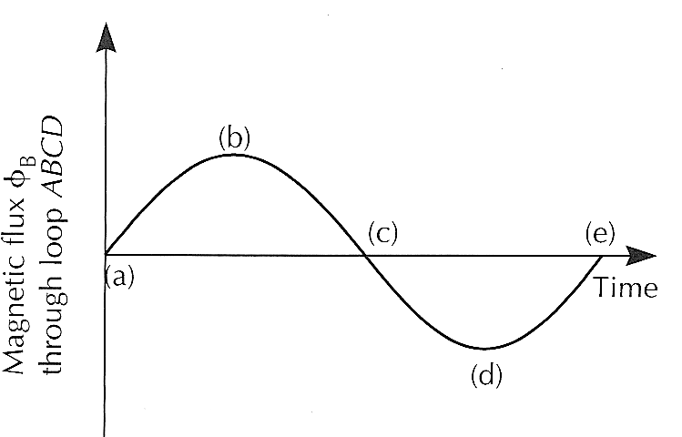

At (a) Coil plane parallel with field, AB rising out of page
- Coil is at its greatest rate of flux change (the turns are slicing through flux at the greatest rate). Therefore max EMF
- Zero flux passing through coil (plane is edge on)
- AB rising out of page, conventional current flow A to D as shown.

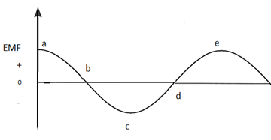

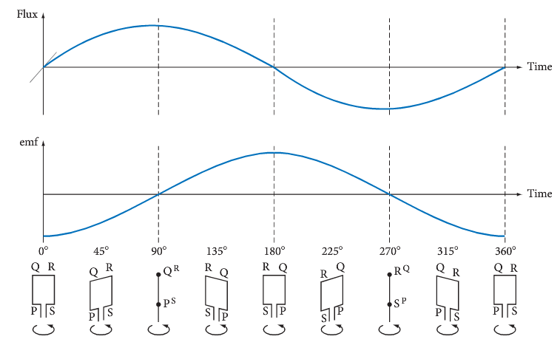

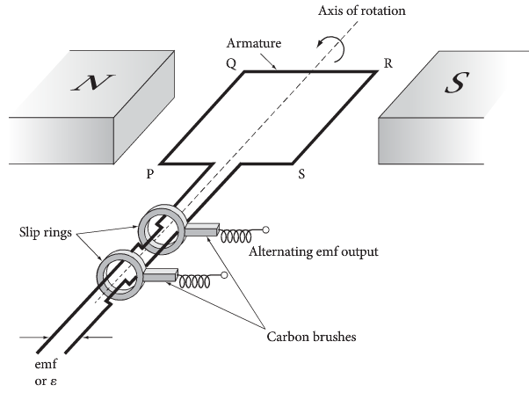

Three Phase Power
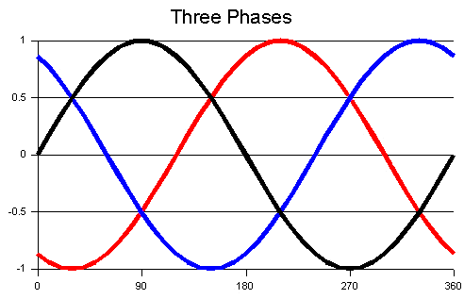
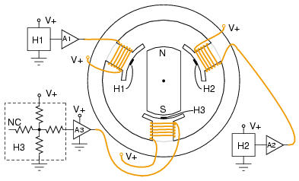

DC generator

- A DC generator is similar to an AC generator, but it will always produce a positive voltage.
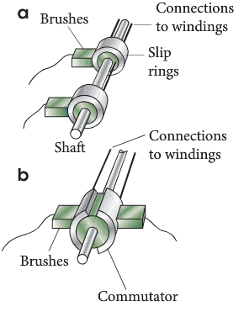
- A commutator is used instead of the slip rings on an AC generator.
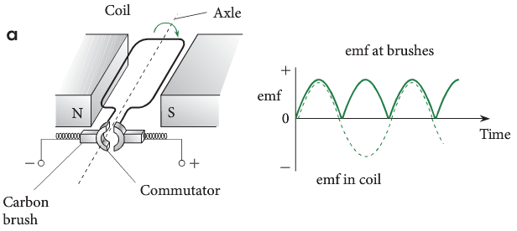

- In the above generator the induced current will move CW – as viewed from above.
- Half a cycle later, the coil has rotated 180° but the current will still move CW. Hence, the RHS of the commutator will always be positive.

- Although the current is always flowing in the same direction, it is described as ‘lumpy’. This can be reduced by having more coils.
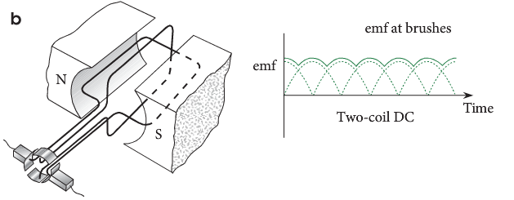

Back EMF in a DC motor

- When the armature of a DC motor rotates under the influence of the driving torque, the armature conductors move through the magnetic field.
- Hence, an EMF is induced in them as in a generator.
- The induced EMF acts in opposite direction to the applied voltage V (Lenz's law) and in known as back or counter EMF.

- The back EMF is always less than the applied voltage, although the difference is small when the motor is running under normal conditions.

CALCULATIONS INVOLVING GENERATORS

- While the formula below has already been seen, it is useful to revisit it with some additional information when completing problems involving emf.
Note:
- Formula assumes constant change in flux and hence we calculate the average emf. Formula does not calculate maximum emf.
- Negative sign in formula relates to Lenz’s Law. Induced magnetic field surrounding the coil is opposite to the change producing the emf.
- Maximum emf occurs when coil is parallel to magnetic field and no emf is induced when coil is perpendicular to field.
- Magnetic flux threading the coil changes from minimum when coil is parallel to field and maximum when coil is perpendicular to field (further explain in next two pages).
- Maximum change in flux and emf occurs each quarter of a turn.

Example
An armature of a small AC generator is rotating at 2000 rpm. through a uniform magnetic field of 2.00 Tesla. If the armature has an area of 0.0055 m² and has 200 turns, find the average emf induced.

Zero flux threading coil maximum flux threading coil
i.e. BA = 2 x 0 i.e. BA = 2 x 0.0055
φ₁ = 0 Wb φ₂ = 0.011 Wb

average emf in ¼ turn so
2000 turns in 60 s
= 0.25 turns in x s emf = -N (φ₂ - φ₁)
t
x = 60 x 0.25 emf = -200 (0.011 – 0)
2000 0.0075
t = 0.0075 s emf = -293 V

- A coil of wire has 50 turns and an area of 6.25 x 10⁻⁴ m². It is rotating steadily at 50.0 revolutions per second about an axis in the plane of the coil at right angles to a uniform field of flux density 0.500 T. What is the average emf induced in the coil?

Some Details About AC

- This diagram represents the variation in EMF with time. It takes 1/50 second for 1 period in Australian mains supply (50Hz).
- The quoted voltage of 240V is actually an RMS (root mean square) value which is 1/√2 = 0.707 of the peak voltage (light line).
- The peak voltage (zero to the top) is around 340V and the peak to peak voltage is 680V.

- RMS values are used in calculation, because they represent the true or average power developed in devices.
- RMS values enable the same calculations as DC equivalent circuits. For example a 60W light bulb results in this calculated value provided I and V are in RMS values.
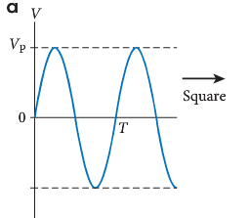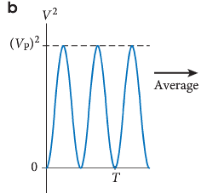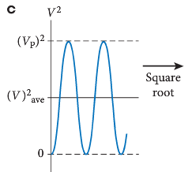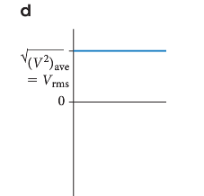
sinusoidal wave for V V² average value of V² $\sqrt{V^{2}}$ = V_{rms}

$$V_{rms}=\frac{1}{\sqrt{2}} V_{peak}=0.707 x V_{peak}$$
- A little thought will show that the light area (equivalent DC voltage x time) = the blue area (varying voltage x time)
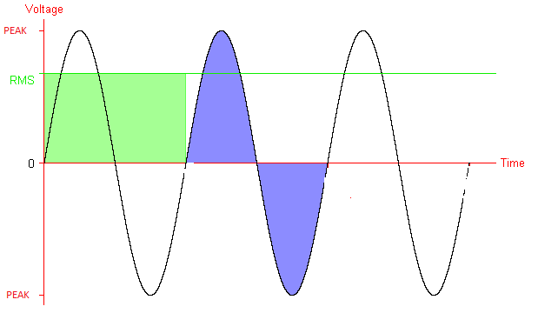

- Show that the peak voltage of 340 V equates to an RMS value of 240 V.

- Most households in WA are connected to the grid with “3 phase” power which involves 4 conductors linking the building to the power lines (3 conductors + a common or shared return).
- These 4 conductors represent 3 circuits, each 120⁰ out of phase with the other. 3 phase power enables appliances designed to operate at more than the single circuit limit of 2400W, to use more than one circuit at a time.

- As seen on the previous graph, voltage produced by a generator is sinusoidal. The maximum emf generated depends on several factors. More voltage is produced when the coil spins faster, the magnetic is high and the number of coils is high.
- A coil of area 0.290 m² is rotating at 70 Hz with the axis of rotation perpendicular to a 0.500 T magnetic field. If the coil has 1500 turns, what is the maximum emf generated in it?

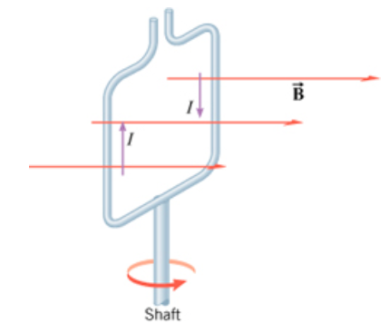
- A square coil of wire, with sides 0.0500 m is rotating at 8.00 Hz through a 0.500 T magnetic field. The coil has 150 turns?

- Calculate the velocity of the edge of the coil.

- Use $emf= -2NlvB$ to calculate the maximum voltage produced.

- Show that $emf= -2πNBAf$ will give the same answer.

- Calculate the average emf using $emf= -N\frac{Δϕ}{t}$

- Calculate ${emf}_{av} \sim \frac{2}{π}{emf}_{max}$

- After the motor is switched on its rate of rotation increases. As this happens the net current in the coil decreases. Clearly explain why this happens.

- The diagram shows the coil ABCD of an AC generator placed between magnetic poles.
- The uniform magnetic field of flux density 0.204 T is indicated.
- The dimensions of the coil are: AB = DC = 16.0 cm and AD = BC = 10.0 cm
- The coil rotates about the axle as indicated as a torque is applied to the pulley.
- The coil has 350 turns of wire and is rotated at 750 rpm.

Contacts to external circuit
Slip rings
Pulley that turns coil
Axle
A
C
B
D
AB rotates into the page
DC rotates out of the page
- Calculate the flux contained within the coil ABCD at the instant shown.

- Draw on the diagram the direction of induced current along AB and DC as the coil rotates from the position shown. Explain briefly how you arrived at your answer.

- To get the coil to turn, a torque is applied on the pulley. Explain why a counter-torque is also applied to the pulley as this happens.

- Calculate the magnitude of the maximum emf from the AC generator.
(3 marks)

- On the axes shown below, sketch the shape of the emf output for this generator as it rotates one full turn from the initial position shown. Add a suitable numerical time scale on the time axis and label your curve ‘750 rpm’.

0.08
0.06
0.04
0.02

- Sketch a second shape of the emf output for a rate of rotation of 1500 rpm and label this curve ‘1500 rpm’.
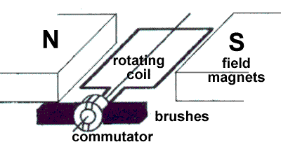
- A typical DC electric motor is shown at right. The coil contains 250 turns and has dimensions of 8.00 cm in length by 5.00 cm in width. The field magnets produce a uniform magnetic field of strength 0.0240 T in which the coil rotates.

Estimate the maximum rotational speed of the motor (in rpm) when connected to a 6.00 V battery and operating under no load.

- A square coil of sides 0.100 m is made up of 400 turns. It is rotated at 25.0 Hz in a magnetic field of magnitude 0.100 T
  - Find the maximum emf induced.
  - If, at t = 0, there is maximum flux through the coil, sketch the emf as a function of time.

EMF (V)
60

30

0

-30

-60
0.12
0.04
0.08
0.16

PP 6.4 p 203-10
WSG 2.6 p79-82 Q’s 35-45 p95-8

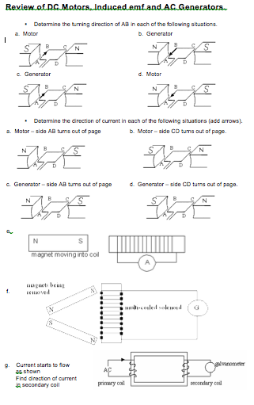
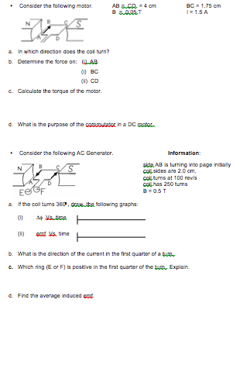

Review of DC Motors, Induced emf and AC Generators.
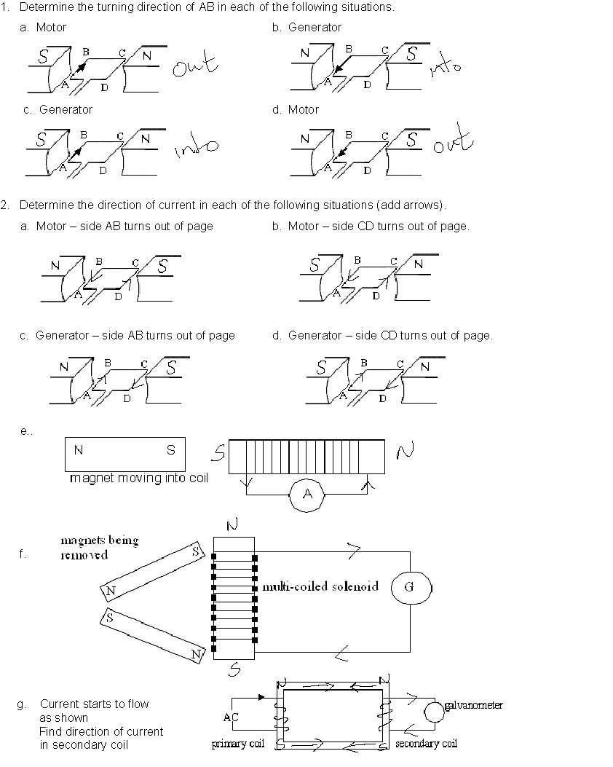
UP
UP
DOWN
DOWN

- Consider the following motor. AB = CD = 4 cm BC = 1.75 cm
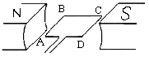B = 0.05 T I = 1.5 A

- In which direction does the coil turn? anticlockwise – AB down, into page

- Determine the force on: (i) AB F = BIl = 0.05 x 0.04 x 1.5 = 3.0 x 10⁻³ N into page
- BC no force
- CD 3.0 x 10⁻³ N out of page

- Calculate the torque of the motor.
τ = 2Fr⊥
= 2 x 3.0 x 10⁻³ x 0.00875
= 5.25 x 10⁻⁵ Nm

- What is the purpose of the commutator in a DC motor.
device that reverses the current flow in the armature coils as coil rotates.

- Consider the following AC Generator. Information:
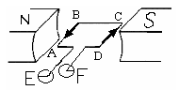
side AB is turning into page initially
coil sides are 2.0 cm,
coil turns at 100 rev/s
coil has 250 turns
B = 0.5 T

- If the coil turns 360⁰, draw the following graphs:
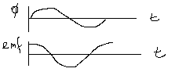
- Δφ Vs time

- emf Vs time

- What is the direction of the current in the first quarter of a turn. B → A

- Which ring (E or F) is positive in the first quarter of the turn. Explain. Positive particles moving from F to E so F must be positive.
- Find the average induced emf.

100 rev = 1 s
0.25 rev = t
t = 0.25 / 100
= 2.5 x 10⁻³ s

φ = 0.5 x 0.02 x 0.02
= 2 x 10⁻⁴ Wb emf = -20 V

Magnetic Field Strength – Summary
- Magnetic field, B, unit tesla, T
- Magnetic field from permanent magnet or electromagnets.
- Given value for B is field strength at that point that causes force to occur
- Field effect for magnets can induce an emf
  - magnets can move into or out of coil
  - coil can move towards or away from magnet
  - area of coil perpendicular to field can change by turning coil
  - coil shape can change so changing induced emf

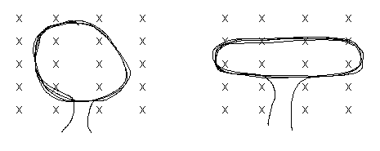
NOTE:
emf = -N (φ₂ - φ₁)
t
Both loops are the same length but the one pulled outwards has less area cut by field so less induced emf as φ = BA
- If using an electromagnet to induce emf in coil, as current through electromagnet can be
changed
  - more rapid field changes induce greater emf
  - emf proportional to rate of change of magnetic flux, φ

Induced EMF - Summary

- Can be increased by
  - increasing movement between conductor (coil) and magnetic field.
  - increase length of conductor in field (more coils)
  - increase strength of magnetic field, B
- emf always induced so as to oppose the magnetic field that created it
- Generators induce an emf which then produces current (covered in next section)
- Maximum emf induced when maximum force possible i.e. when coil is parallel to magnetic field
- Minimum emf induced when minimum force possible i.e. when is perpendicular to field
- Diagram below shows coil turning from maximum emf to minimum emf in ¼ turn.

Coil at parallel to Coil at 45⁰ to Coil perpendicular to
field - emf maximum field emf half max value field - emf zero
as maximum force as force = F cos 45 as force on coil zero
(note: minimum area of (note: maximum area of coil
coil to field so magnetic to field so magnetic flux is
flux is zero) maximum value)

- This now explain the graph of emf versus time.
For a coil starting as shown and rotating clockwise 360⁰
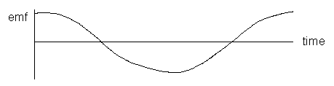
Note:
Compare graphs of emf VS time to magnetic flux VS time, note that graphs are opposite.

TRANSFORMERS
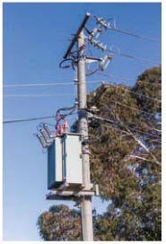
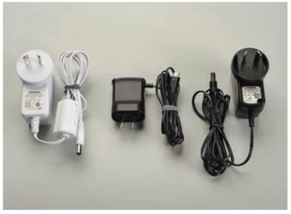
- Transformers change the magnitude of the voltage supplied in an A.C. system to a higher or lower voltage, and/or to a D.C. current.

- Consider a coil – call this the Primary Coil
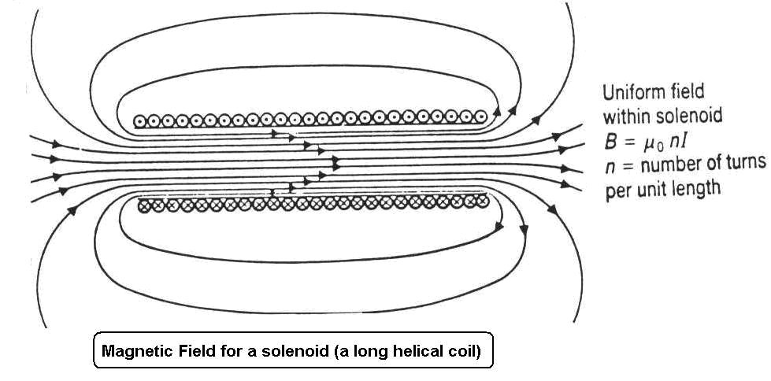

- The current in the coil creates a magnetic field. If a second coil is placed near, what happens?

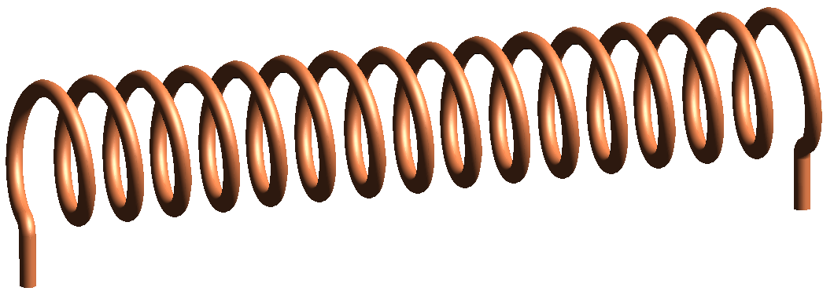


I_{in}

I_{in}
I_{out}

- As the current in the primary coil is changing, the magnetic field is changing. A changing magnetic field induces a current in the second coil, now called the Secondary Coil - this is called mutual induction.
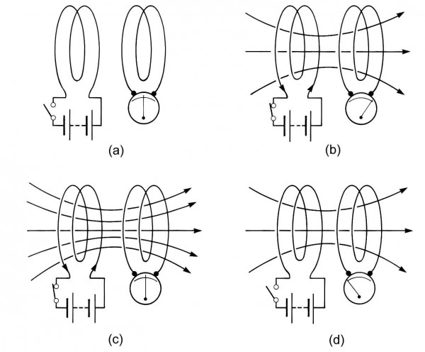
- If a soft iron core is inserted in the coils the emf is enhanced (iron increases the overall magnetic flux in the coils).
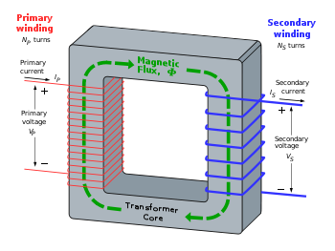

- If the number of coils (turns) on the two coils is different, the voltage can be changed.
Vs = Ns
Vp Np

- If Np >Ns - decrease in voltage of the secondary coil - STEP DOWN TRANSFORMER
If Np < Ns - increase in voltage of the secondary coil - STEP UP TRANSFORMER

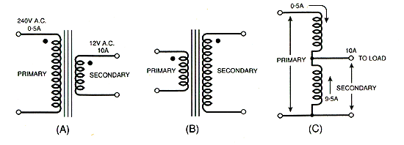
- Symbols
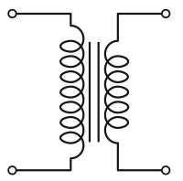

Step Up Transformer
Step Down Transformer

Uses for Transformers

- In power transmission.
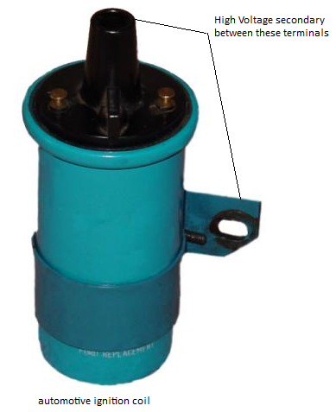
- Most domestic/commercial electronic devices (computers, stereos, TV) use only a few volts DC to operate many of the semiconductor based circuits.
- Petrol driven vehicles need to supply several thousand volts across spark plug gaps to ignite fuel. With only a 12V DC supply, a “coil” (automotive speak for an automotive transformer) is used. In the absence of a source of AC, the primary coil is has its 12V DC supply switched on and off at the right time by “point contacts”.
- The induction coil – a device for converting low voltage DC into a high voltage EMF.
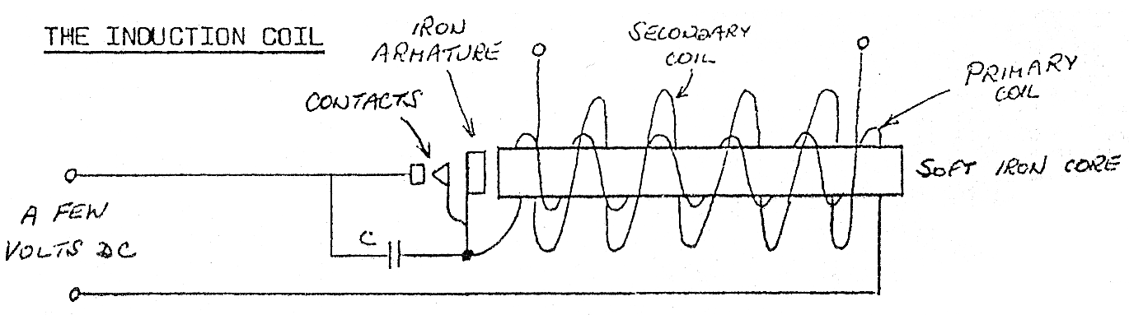

PP 6.4 p 210-4
WSG 2.7 p82-3

Electrical Power
- Power is the rate at which energy (work) is produced or used, therefore power is equal to the work done divided by the time taken. The unit for power is the watt (W).

but we also know that work, W = Vq
therefore we can say that
now current is described as the rate of flow of charge or
therefore P = Vq = VI where V = potential difference (V)
OR P = VI P = power (W)
I = current (A)

- Using Ohm’s Law, V = IR, two other formulas for power can be derived:
P = I²R and
- These last two formulas will not be given to you in your data sheet.

Electrical Energy Used
- The energy consumed by an electrical appliance depends upon the rate of energy use (power rating) and the time for which it is operating. Knowing that work is equivalent to energy,

W = Pt or E = Pt
but P = VI so substituting for P,
E = VIt where E = energy used (or work done) in joules (J)
V = potential difference supplied (V)
I = current (A)
t = operating time (s)

- A motor car’s two headlights are each rated at 50.0 W and operate on a 12.0V power supply.
Calculate the following:
- The current flowing in each headlight when they are in use.

- The charge passing through each globe every second.

- The total energy consumed by the two headlights during a 2.00 hour night journey.

- What is the current drawn by a 2.50 x 10³ W electric kettle if is operates on a 240 V supply?

- If the kettle in question 2 is used for 2.80 minutes, how much electrical energy will it use?

- A heating appliance is rated at 2.40 kW with a current of 10.0 A. Determine
  - the PD across the appliance,

- amount of heat converted from electrical energy per minute.

- the total charge flowing through it per minute.

WSG 2.7 p84

POWER ACROSS THE COUNTRY

Electric Power System

- Electricity is generated when a loop of conducting wire rotates in a magnetic field. In a hydroelectric plant, water falling over a dam turns turbines that spin the generators that produce electricity.
- The electricity flows to a transmission station where a transformer changes a large current and low voltage into a small current and high voltage.
- Then the electricity flows over high voltage transmission lines to a series of transmission stations where the voltage is stepped down by transformers to levels appropriate for distribution to customers.
- Primary lines may transmit electricity at voltages as high as 500,000 volts. Secondary lines to homes carry electricity at 240 V.
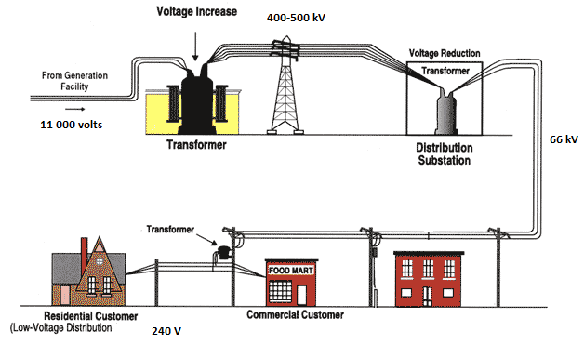

POWER TRANSMISSION

- Power stations produce large currents, as much as 20 000 A. This requires very thick and expensive cable to carry it about the country.
- We know that P = VI. We don’t want the power to change, however if we increase the voltage we can decrease the current.
- A smaller current can be carried on thinner, lighter cables reducing cost.
- Transformers are used to change the magnitude of the voltage.

- Power lost as heat is equal to P = I²R. The resistance remains unchanged so if we decrease the current, say by 10, this will result in a decrease in power loss of 100. An equally important reason to use a high voltage.

- 8.00 kW of power is produced by an AC generator and this is transmitted at 240 V down a line which is 5.0 km long. If the wire has a resistance of 0.40 Ω km⁻¹, calculate:
a. the power lost in the line.
b. the voltage which reaches the end of the line

- In the above situation, before the current is sent along the lines the voltage is stepped up to 5000 V.
a. Determine the loss of voltage
b. Compare the efficiency in each situation.

- A hospital generator, 800m from the hospital, generates 40 kW at 250V AC for emergency use. The connecting transmission lines have a total resistance of 0.20 Ω.

a) How much power is lost in the transmission line?

b) What would the voltage be at the hospital?

PP 6.4 p 214-7 6.4 Review p 218-9 Chapter review p 220-4
WSG 2.7 p85-6 46-50 p98-9

REVISION ELECTRIC POWER.

- Why should you not place a cassette tape near electrical cords?

- A beam of electrons is travelling at 5.00 x 10⁶ ms⁻¹ and is moving from left to right into a magnetic field that is directed vertically upwards. Find the magnitude and direction of the force acting on each electron if the field has an intensity of 8.00 x 10⁻⁵ T

- What is the radius of curvature of the path of the electron in question 2?

- Imagine you are driving a truck at 90.0 kmh⁻¹ in a region where the vertical component of the earth’s magnetic field is 4.0 x 10⁻⁵ T. If an axle of the truck is 1.52 m long, calculate the emf generated across it.

- Find the emf generated in the wings of an aircraft travelling horizontally at 597 ms⁻¹ if the wing span is 25.0 m and the vertical component of the earth’s magnetic field has a flux density of 5.00 x 10⁻⁵ T?

- A coil of 1 000 turns is threaded by a flux of 0.85 Wb. If the flux is then reduced to 0.15 Wb in 2.5 ms, what is the average emf induced in the coil?

- A coil in a small motor has 100 turns. The shape of the coil is 10 cm long by 4 cm wide. It carries a current of 5 A when the field strength is 0.08 T. Calculate the torque on the coil.

- A ticker timer is a device used to produce regular vibrations of a striker on a tape to measure the velocity and/or acceleration of the tape.
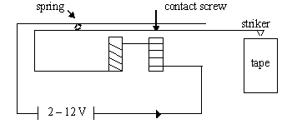

- When the power is momentarily switched on, the striker will hit the tape, explain why.
- Once the power remains on the striker will vibrate. Explain why
- How could the devise be changed to make the striker hit harder?
- Why are the coils wound in opposite directions?

- Look at the following simple motor.

- If the coil is parallel, when switched on, which way will the side AB move?
- Why does the coil rotate when the current is switched on?
- How would you make the coil turn faster?

- When two conductors next to each other have currents running in opposite directions,
- what would happen to the conductors?
- draw the fields.

- Find the emf generated in the wings of an aircraft travelling horizontally at 5.97 x 10² ms⁻¹ if the wings span is 25.0 m and the vertical component of the earth’s magnetic field has a flux density of 5.00 x 10⁻⁵ T.

- The rate of blood-flow can be measured by the apparatus below since blood contains charged ions.
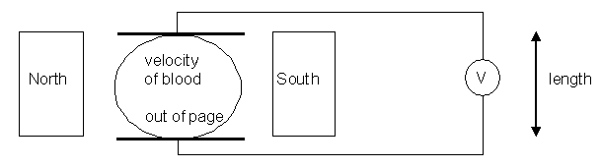
Suppose that the blood vessel is 2.0 mm in diameter, the magnetic field is 0.08 T, and the
measured emf is 0.1 mV. What is the flow velocity of the blood?

- You set up a solenoid attached to a sensitive galvanometer (measures very small changes in current) to investigate Lenz’s law. For each of the following situations, say whether the current will flow through the galvanometer in direction A or B (if no current, say ‘no current’).
a.
S N

magnet moving into coil A B
A

b.
N S

magnet moving away from coil A B

c. S N
ACME
Electromagnet
A B
Power supply
on Electromagnet turned on and up to strength

d. S N
ACME
Electromagnet
A B
Power supply
on
Electromagnet left at high strength for 60 s.
e. S N
ACME
Electromagnet
A B
Power supply
off
Electromagnet switched off

Unit 3 Review p 225-8

